VIETNAM GENERAL CONFEDERATION OF LABOUR

**TON DUC THANG UNIVERSITY**

**FACULTY OF INFORMATION TECHNOLOGY**



**THE FINAL PROJECT OF SOFTWARE TECHNOLOGY**

**CONVENIENCEN STORE**

Instructor: **Mr. LÊ NGỌC THẠCH**

Executor: **LÊ TUẤN KIỆT– 518H0523**

**LỮ TRỌNG PHÚ – 518H50523**

**TRẦN NGUYỄN HOÀNG MINH – 518H0523**

Class:**18H50202**

Course:**22**

**HO CHI MINH CITY, 2020**

**THANKS**

During the research process for the major assignment, I have received enthusiastic suggestions and help from teachers, so these sincere thanks would be sent to:

* Firstly, I would like to express my sincere gratitude to my supervisor teacher – Mr. LÊ NGỌC THẠCH, who taught and conveyed experiences to me directly during my studying and conducting this research process.
* Besides, I am thoroughly grateful to all teachers of the Faculty of Information Technology in TDT University for giving me a chance to study and contact with my major.

**THIS PROJECT WAS ACCOMPLISHED AT TON DUC THANG** **UNIVERSITY**

I commit that this product belongs to us with the guardian of Mr. LÊ NGỌC THẠCH. The content of the research, result of this project is honest and has not been published in any form before. The data in the tables for analysis, comment and evaluation were collected by the author from various sources in the reference section.

Besides, our project used many kinds of comments, assessments as well as data from other authors, organizations. This project has original quotes and annotations.

If any fraud is detected, I will take full responsibility for the contents of my project. Ton Duc Thang University is not involved to any violations of copyright and copyright caused by me during implementation (if any).

*Ho Chi Minh City, November 30th, 2020*

*Author Author*

*(Sign and write full name) (Sign and write full name)*

*Lê Tuấn Kiệt Lữ Trọng Phú*

*Author*

*(Sign and write full name)*

*Trần Nguyễn Hoàng Minh*

**CONFIRMATION AND EVALUATION OF LECTURERS**

**Confirmation of lecturers**

_____________________________________________________________________________________________________________________________________________________________________________________________________________________________________________________________________________________________________________________________________________________________________

Ho Chi Minh City, May 17th 2020

(Sign and write full name)

**Evaluation of lecturers**

_____________________________________________________________________________________________________________________________________________________________________________________________________________________________________________________________________________________________________________________________________________________________________

Ho Chi Minh City, May 17th 2020

(Sign and write full name)

**Table of contents**

**CHAPTER 1: EXECUTIVE SUMMARY**

1. **Introduction**
   1. **Description**

* Sales management system aims to create a sales management system including the functions:

+ Employee management.

+ Customer management.

+ Manage import and export.

+ Manage existing items in the store

+ Financial management, revenue and expenditure of the store

* The system design will be released under the title of Convenience Store and the initial release is expected to be 1.0 (though this is subject to change). Further iterations of the application are bound to occur and thus this first system should be considered as the base model with room to grow and evolve as the end customer’s requirements change.
* It is expected that the relevant test and development plan documents will be created based on the information provided within this document and should be referenced accordingly.
* Convenience Store workflow will be in three deliverables.
* Use case model survey: Use case model survey includes a list of actors and use case diagrams.
* Domain object model (optional): The deliverables of this activity are collaboration, sequence, and class diagrams for each use case.
* Detailed use case description for every use case: These documents drive the development in future phases of developing a software system.

**CHAPTER 2: BUSINESS REQUIREMENTS**

1. **User requirement**
2. **List of Requirement**

|  |  |
| --- | --- |
| Code require | Require name |
| RQ01 | Staff log in to the system |
| RQ02 | Bill of sale |
| RQ03 | Product inventory |
| RQ04 | Manage Store |

1. **Staff Login**

|  |  |
| --- | --- |
| Code require | RQ01 |
| Require name | Staff log in to the system |
| Purpose | Allow Staff log in to the system by using username and password has been provided |
| Object | Staff in the store |
| Pre-conditions | Staff login successfully |
| Treatment | *) The form of “Nhân Viên” include:  - Mã Nhân Viên (ID Staff)   * - Họ và Tên (Name of Staff) * - Năm sinh (Date of birth) * - Giới Tính (Sex) * - Địa Chỉ (Address) * - Số điện thoại (Phone number) * *) Display data of Staff, but they don’t allow to edit, delete, add * *) Have a taskbar in the top include “Thông in”,” Hóa Đơn”, “Hàng hóa” |

1. **Bill of sale**

|  |  |
| --- | --- |
| Code require | RQ02 |
| Require name | Bill of sale |
| Purpose | Allow Staff to access form “Hóa Đơn Bán Hàng” (Bill off sale) |
| Object | Staff in the store |
| Pre-conditions | Staff access successfully |
| Treatment | * *) When Staff are in form “Nhân Viên”, they click the button “hoá đơn” in the taskbar, form “Hóa Đơn” will display and close the previous form. * The form “Hóa Đơn” include: * - Mã Hàng (ID’s product) * - Tên Hàng (Name of product) * - Mô Tả (Description) * - Đơn Giá (Price) * - Mã Hóa Đơn (ID’s Bill) * - Số Lượng (Amount) * - Mã nhân viên (ID’s Staff) * *) There have buttons “Thêm” (Add product), “Xóa” (Delete product), “Sửa” (Edit product) in the left   *) There have buttons “In Hóa Đơn” (Print the bill), “Lưu Hóa Đơn” (Save the bill), “Xem Trước Hóa Đơn” (Preview the bill), “Thoát” (Exit)   * *) Display data of product in bill of sale and allow Staff (this time could be The Salesman) to do all the function |

1. **Product Inventory**

|  |  |
| --- | --- |
| Code require | RQ03 |
| Require name | Product inventory |
| Purpose | Allow Staff to access form “Kiểm Kê Hàng Hóa” (Product inventory) |
| Object | Staff and Store Manager in the store |
| Pre-conditions | Staff and Store Manager access successfully |
| Treatment | *) The form name “Kiểm Kê Hàng Hóa” include:   * - Mã Hàng (ID’s product) * - Tên Hàng (Name of product) * - Mô Tả (Description) * - Đơn Giá (Price) * - Mã Hóa Đơn (ID’s Bill) * - Số Lượng (Amount) * - Mã nhân viên (ID’s Staff) * *) There have buttons “Thêm” (Add product), “Xóa” (Delete product), “Sửa” (Edit product) * *) Display data of product in form “Kiểm Kê Hàng Hóa” (Product Inventory) and allow Staff and Store Manager to do all the function |

1. **Manage Store**

|  |  |
| --- | --- |
| Code require | RQ04 |
| Require name | Manage Store |
| Purpose | Allow Store Manager to access form “Kiểm Kê Hàng Hóa” (Product inventory) and form “Quản Lý Nhân Viên” (Manage Staff) |
| Object | Store Manager |
| Pre-conditions | Store Manager access successfully |
| Treatment | *) The form name “Quản Lý Nhân Viên (Manage Staff)” include:  - Mã Nhân Viên (ID Staff)   * - Họ và Tên (Name of Staff) * - Năm sinh (Date of birth) * - Giới Tính (Sex) * - Địa Chỉ (Address) * - Số điện thoại (Phone number) * *) There have buttons “Thêm” (Add Staff), “Xóa” (Delete Staff), “Sửa” (Edit Staff Information) and Store Manager can do all the function * *) Display data of Staff in form “Quản Lý Nhân Viên” (Manage Staff)   *) The form name “Quản Lý Hàng Hóa” (Manage Product) include:   * - Mã Hàng (ID’s product) * - Tên Hàng (Name of product) * - Mô Tả (Description) * - Đơn Giá (Price) * - Mã Hóa Đơn (ID’s Bill) * - Số Lượng (Amount) * - Mã nhân viên (ID’s Staff) * *) There have buttons “Thêm” (Add Product), “Xóa” (Delete Product), “Sửa” (Edit Product Infomation) and Store Manager can do all the function * *) Display data of Product in form “Quản Lý Hàng Hóa” (Manage Product) |

**CHAPTER 3: SYSTEM RESQUIREMENTS SPECIFICATION**

* 1. **Actor**
* Customer:

+ Customers are people who buy from the store.

* Staff:

+ Staff will manage the number of goods in the warehouse, inventorying the goods.

+ The salesman (staff) will make a bill for customers.

* The Store Manager:

+ The Store Manager will directly contact the manufacturer to import goods into the store, as well as have a relationship with partners to sell out. The Store Manager will manage Staff information in the store.

1. **High – Level Requirement**
   1. **User story**

* **Staff**:

+ Staff will log in to the application by using their username and password has been provided.

+ **Staff** will manage the number of goods in the warehouse, inventorying the goods by using the application and it’ll auto calculate to support staff

+ **The salesman** (**Staff**) will make a bill for customers by using the application. When **the salesman** scan the barcode, it’ll display the product on the screen and it can calculate all the gross product.

* **The Store Manager:**

+ **The Store Manager** will manage the Staff and all the product. All information about **Staff** will be managed by **The Store Manager**.

+ The recruitment of staff and fire will be in charge of **Store Manager**.

**The Store Manager** will directly contact the manufacturer to import goods into the store, as well as have a relationship with partners to sell out.

* 1. **Use case Description**
     1. **Use case diagram**

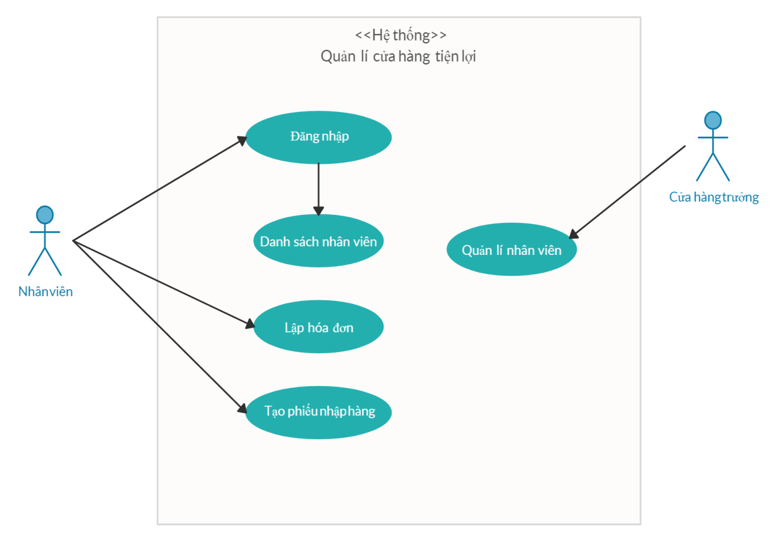

* + 1. **List of Use case**

|  |  |
| --- | --- |
| Uses Cases | Use Cases Goals |
| Customer | * Find product/items * Buy product/items * Confirm product/items |
| The Salesman (Staff) | * Log in to system * Make a bill |
| Staff | * Import product/items * Check product/items * Update product/items |
| Store Manager | * Statistics * Product/items management * Staff management |

* + 1. **Log in**

|  |  |
| --- | --- |
| Use case name | * Log in to the staff system |
| Situations | * Staff and Store manager wants to log in to the store’s system |
| Activation conditions | * Staff and Store manager log in to system |
| Objects | * Staff and Store manager |
| Necessary condition | * Pre-made Staff accounts * Account has been authorized * The device must be connected to the internet |
| Sufficient conditions | * Staff logged in successfully * Logging system |
| Main - event | * Staff log in to form Log in * Input username and password * Click button “Login” * The system will check the login information * Login successful will redirect to the appropriate page |
| Sub - event | * Invalid or wrong login accounts * Request user login again |

**1.2.3. Staff information**

|  |  |
| --- | --- |
| Use case name | * Staff information |
| Situations | * Staff want to see staff information |
| Activation conditions | * Staff log in to the system |
| Objects | * Staff |
| Necessary condition | * Must log in to the store system |
| Sufficient conditions | * None |
| Main - event | * Staff will choose the staff’s information function * The system will show the staff's information on the screen |
| Sub - event | * None |

**1.2.4. Make a bill**

|  |  |
| --- | --- |
| Use case name | * Make a bill |
| Situations | * The salesman(staff) will choose the function of invoicing to calculate and invoice for customers. |
| Activation conditions | * The salesman(staff) log in to the system |
| Objects | * The salesman(staff) |
| Necessary condition | * The customer buys the item at the store and wants to pay * There are item codes, unit prices updated in the system |
| Sufficient conditions | * Print the bill for customer |
| Main - event | * Staff scans the code of each item * The system will automatically calculate the total amount which is the customer must pay based on the quantity and price of the item * Staff print the bill for customer |
| Sub - event | * None |

* + 1. **Create an import slip**

|  |  |
| --- | --- |
| Use case name | * Create an import item slip |
| Situations | * The staff wants to create a receipt to import goods into the warehouse. |
| Activation conditions | * Staff log in to the system |
| Objects | * Staff |
| Necessary condition | * Import items required |
| Sufficient conditions | * Print items receipt |
| Main - event | * Staff will choose the function to create an item to import slip * The system will require to input items information into the item entry form * Staff input the information * The system will provide the code item entry slip and saves the information * The system print the import coupon |
| Sub - event | * None |

* + 1. **Staff manager**

|  |  |
| --- | --- |
| Use case name | * Staff manager |
| Situations | * The Store Manager wants to manage staff information. |
| Activation conditions | * The Store Manager log in to the system |
| Objects | * The Store Manager |
| Necessary condition | * Must login to store’s system * Must be Store Manager |
| Sufficient conditions | * None |
| Main - event | * Store Manager login successfully * The system will display all staff information in the store |
| Sub - event | * None |